Web Project

**C.Dcar deals**

**Name___________________________________________**

**S/O _____________________________________________**

**Session ________________________To_________________**

**Roll No____________________________________________**

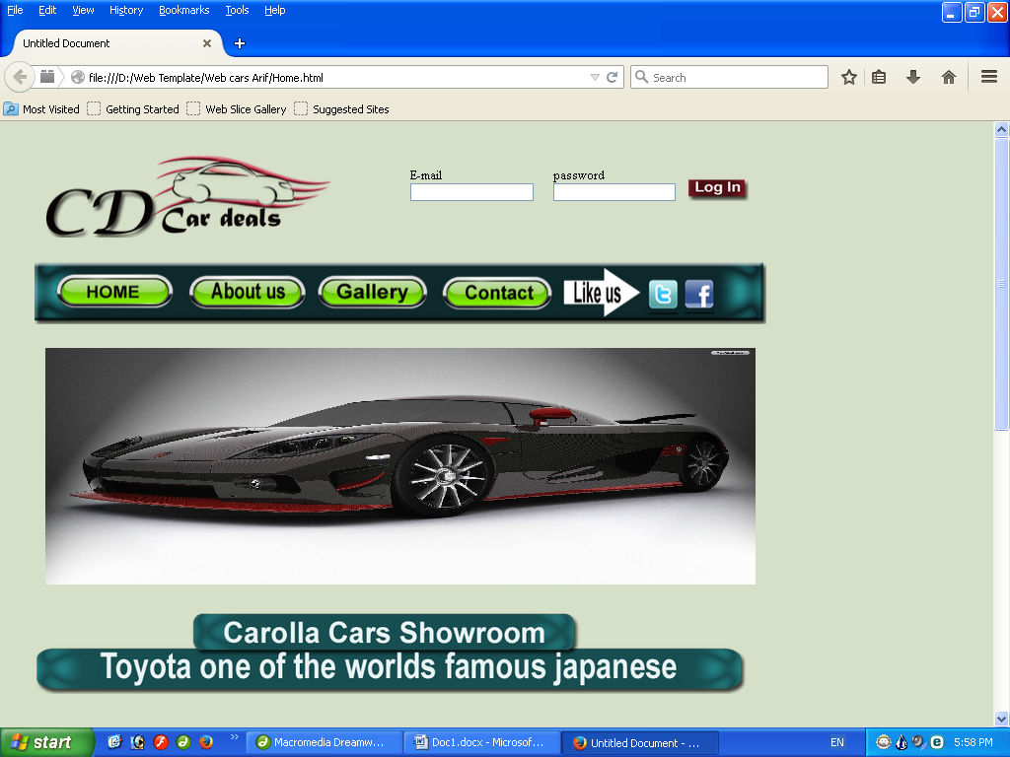

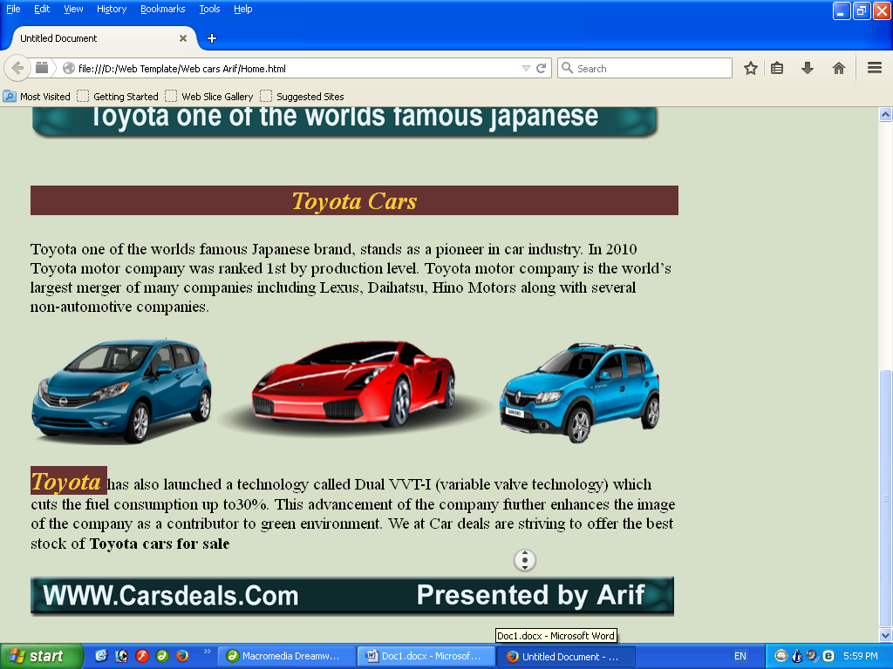

**Page Home**

<!DOCTYPE html PUBLIC "-//W3C//DTD XHTML 1.0 Transitional//EN" "http://www.w3.org/TR/xhtml1/DTD/xhtml1-transitional.dtd">

<html xmlns="http://www.w3.org/1999/xhtml">

<head>

<meta http-equiv="Content-Type" content="text/html; charset=iso-8859-1" />

<title>Untitled Document</title>

<style type="text/css">

<!--

.style1 {

font-size: 36px;

font-weight: bold;

}

.style2 {font-size: 24px}

-->

</style>

<link href="C.S.S/Untitled-1.css" rel="stylesheet" type="text/css" />

<style type="text/css">

<!--

body {

background-color: #d6dfc7;

}

-->

</style></head>

<body>

<table width="1000">

<tr>

<td><table width="950" align="center">

<tr>

<td width="9">&nbsp;</td>

<td width="376">&nbsp;</td>

<td width="14">&nbsp;</td>

<td width="516">&nbsp;</td>

<td width="11">&nbsp;</td>

</tr>

<tr>

<td>&nbsp;</td>

<td><img src="images/Arif_03.png" width="374" height="109" /></td>

<td>&nbsp;</td>

<td><table width="512" height="72">

<tr>

<td width="80">&nbsp;</td>

<td width="145"><form id="form1" name="form1" method="post" action="">

<label>E-mail

<input type="text" name="textfield" />

</label>

</form> </td>

<td width="19">&nbsp;</td>

<td width="144"><form id="form2" name="form2" method="post" action="">

<label>password

<input type="text" name="textfield2" />

</label>

</form> </td>

<td width="100" align="center" valign="bottom"><img src="images/Arif_06.png" width="80" height="30" border="0" usemap="#Map2" /></td>

</tr>

<tr>

<td height="21" colspan="5">&nbsp;</td>

</tr>

</table></td>

<td>&nbsp;</td>

</tr>

<tr>

<td>&nbsp;</td>

<td>&nbsp;</td>

<td>&nbsp;</td>

<td>&nbsp;</td>

<td>&nbsp;</td>

</tr>

</table>

<table width="950" align="center">

<tr>

<td>&nbsp;</td>

<td><img src="images/Arif_11.png" width="927" height="81" border="0" usemap="#Map" /></td>

<td>&nbsp;</td>

</tr>

<tr>

<td>&nbsp;</td>

<td>&nbsp;</td>

<td>&nbsp;</td>

</tr>

</table>

<table width="950" align="center">

<tr>

<td>&nbsp;</td>

<td><div align="center">

<object classid="clsid:D27CDB6E-AE6D-11cf-96B8-444553540000" codebase="http://download.macromedia.com/pub/shockwave/cabs/flash/swflash.cab#version=7,0,19,0" width="900" height="300">

<param name="movie" value="Templates/Arif 1.swf" />

<param name="quality" value="high" />

<embed src="Templates/Arif 1.swf" quality="high" pluginspage="http://www.macromedia.com/go/getflashplayer" type="application/x-shockwave-flash" width="900" height="300"></embed>

</object>

</div></td>

<td>&nbsp;</td>

</tr>

<tr>

<td>&nbsp;</td>

<td>&nbsp;</td>

<td>&nbsp;</td>

</tr>

</table>

<table width="950" align="center">

<tr>

<td>&nbsp;</td>

<td><img src="images/Arif_15.png" width="901" height="104" /></td>

<td>&nbsp;</td>

</tr>

<tr>

<td>&nbsp;</td>

<td>&nbsp;</td>

<td>&nbsp;</td>

</tr>

</table>

<table width="950" align="center">

<tr>

<td>&nbsp;</td>

<td><p align="center" class="faraz">Toyota Cars </p>

<span class="style2">Toyota one of the worlds famous Japanese brand, stands as a pioneer in car industry. In 2010 Toyota motor company was ranked 1st by production level. Toyota motor company is the world&rsquo;s largest merger of many companies including Lexus, Daihatsu, Hino Motors along with several non-automotive companies.</span><br /></td>

<td>&nbsp;</td>

</tr>

<tr>

<td>&nbsp;</td>

<td>&nbsp;</td>

<td>&nbsp;</td>

</tr>

</table>

<table width="950" align="center">

<tr>

<td>&nbsp;</td>

<td><img src="images/Log_19.png" width="901" height="154" /></td>

<td>&nbsp;</td>

</tr>

<tr>

<td>&nbsp;</td>

<td>&nbsp;</td>

<td>&nbsp;</td>

</tr>

</table>

<table width="950" align="center">

<tr>

<td>&nbsp;</td>

<td><span class="style2"><strong class="faraz">Toyota </strong>has also launched a technology called Dual VVT-I (variable valve technology) which cuts the fuel consumption up to30%. This advancement of the company further enhances the image of the company as a contributor to green environment. We at Car deals are striving to offer the best stock of <strong>Toyota cars for sale</strong></span></td>

<td>&nbsp;</td>

</tr>

<tr>

<td>&nbsp;</td>

<td>&nbsp;</td>

<td>&nbsp;</td>

</tr>

</table>

<table width="950" align="center">

<tr>

<td>&nbsp;</td>

<td><img src="images/Log-In_23.png" width="923" height="60" /></td>

<td>&nbsp;</td>

</tr>

<tr>

<td>&nbsp;</td>

<td>&nbsp;</td>

<td>&nbsp;</td>

</tr>

</table></td>

</tr>

</table>

<map name="Map" id="Map">

<area shape="rect" coords="782,25,817,58" href="#" /><area shape="rect" coords="826,25,859,59" href="#" /><area shape="rect" coords="40,24,160,56" href="Home.html" />

<area shape="rect" coords="210,25,332,60" href="About us.html" />

<area shape="rect" coords="367,27,484,56" href="gallery 1.html" />

<area shape="rect" coords="529,26,646,55" href="Contect.html" />

<area shape="rect" coords="786,26,814,58" href="#" /><area shape="rect" coords="825,26,858,60" href="#" /></map>

<map name="Map2" id="Map2"><area shape="rect" coords="8,2,76,29" href="#" /></map></body>

</html>

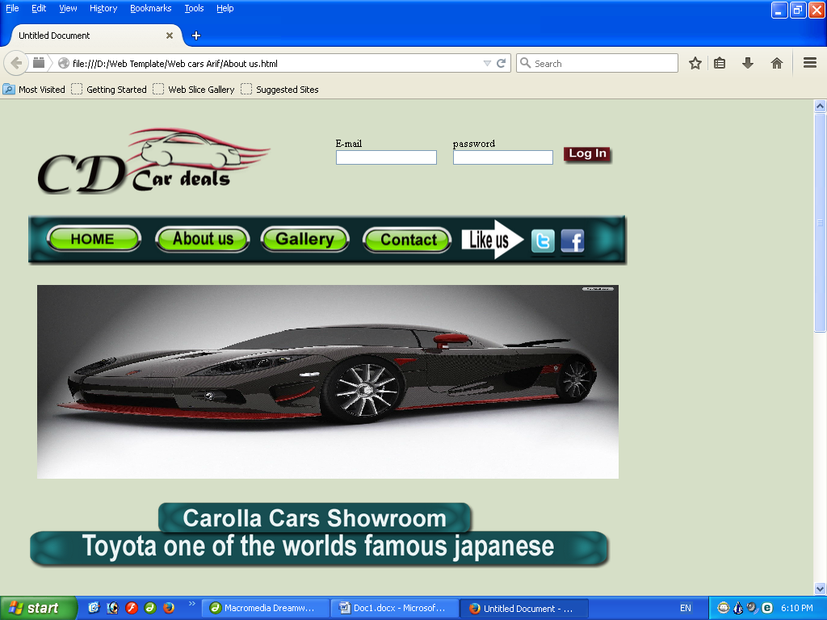

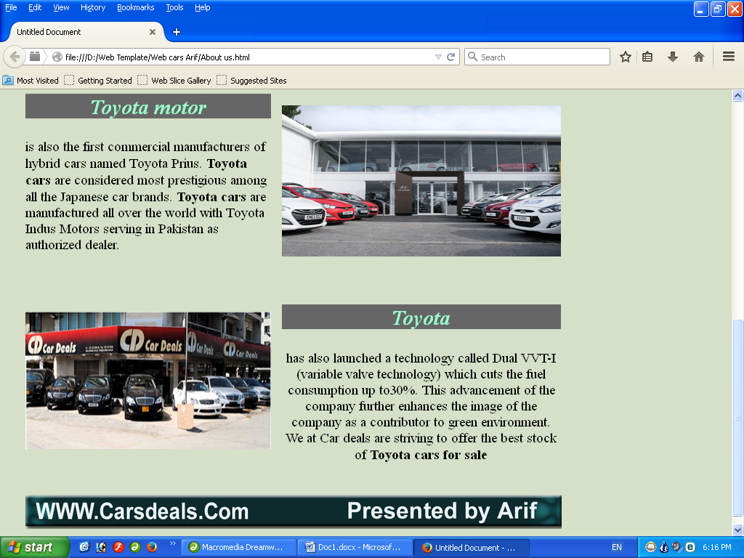

**Page About us**

<!DOCTYPE html PUBLIC "-//W3C//DTD XHTML 1.0 Transitional//EN" "http://www.w3.org/TR/xhtml1/DTD/xhtml1-transitional.dtd">

<html xmlns="http://www.w3.org/1999/xhtml">

<head>

<meta http-equiv="Content-Type" content="text/html; charset=iso-8859-1" />

<title>Untitled Document</title>

<style type="text/css">

<!--

.style2 {font-size: 24px}

.style3 {

font-size: 36px;

font-weight: bold;

color: #FF0000;

}

body {

background-color: #d6dfc7;

}

-->

</style>

<link href="C.S.S/Untitled-2.css" rel="stylesheet" type="text/css" />

<style type="text/css">

<!--

.style5 {color: #0000FF}

-->

</style>

</head>

<body>

<table width="1000">

<tr>

<td><table width="950" align="center">

<tr>

<td width="9">&nbsp;</td>

<td width="376">&nbsp;</td>

<td width="14">&nbsp;</td>

<td width="516">&nbsp;</td>

<td width="11">&nbsp;</td>

</tr>

<tr>

<td>&nbsp;</td>

<td><img src="images/Arif_03.png" width="374" height="109" /></td>

<td>&nbsp;</td>

<td><table width="512" height="72">

<tr>

<td width="80">&nbsp;</td>

<td width="145"><form id="form1" name="form1" method="post" action="">

<label>E-mail

<input type="text" name="textfield" />

</label>

</form> </td>

<td width="19">&nbsp;</td>

<td width="144"><form id="form2" name="form2" method="post" action="">

<label>password

<input type="text" name="textfield2" />

</label>

</form> </td>

<td width="100" align="center" valign="bottom"><img src="images/Arif_06.png" width="80" height="30" border="0" usemap="#Map2" /></td>

</tr>

<tr>

<td height="21" colspan="5">&nbsp;</td>

</tr>

</table></td>

<td>&nbsp;</td>

</tr>

<tr>

<td>&nbsp;</td>

<td>&nbsp;</td>

<td>&nbsp;</td>

<td>&nbsp;</td>

<td>&nbsp;</td>

</tr>

</table>

<table width="950" align="center">

<tr>

<td>&nbsp;</td>

<td><img src="images/Arif_11.png" width="927" height="81" border="0" usemap="#Map" /></td>

<td>&nbsp;</td>

</tr>

<tr>

<td>&nbsp;</td>

<td>&nbsp;</td>

<td>&nbsp;</td>

</tr>

</table>

<table width="950" align="center">

<tr>

<td>&nbsp;</td>

<td><div align="center">

<object classid="clsid:D27CDB6E-AE6D-11cf-96B8-444553540000" codebase="http://download.macromedia.com/pub/shockwave/cabs/flash/swflash.cab#version=7,0,19,0" width="900" height="300">

<param name="movie" value="Templates/Arif 1.swf" />

<param name="quality" value="high" />

<embed src="Templates/Arif 1.swf" quality="high" pluginspage="http://www.macromedia.com/go/getflashplayer" type="application/x-shockwave-flash" width="900" height="300"></embed>

</object>

</div></td>

<td>&nbsp;</td>

</tr>

<tr>

<td>&nbsp;</td>

<td>&nbsp;</td>

<td>&nbsp;</td>

</tr>

</table>

<table width="950" align="center">

<tr>

<td>&nbsp;</td>

<td><img src="images/Arif_15.png" width="901" height="104" /></td>

<td>&nbsp;</td>

</tr>

<tr>

<td>&nbsp;</td>

<td>&nbsp;</td>

<td>&nbsp;</td>

</tr>

</table>

<table width="950" align="center">

<tr>

<td width="1">&nbsp;</td>

<td width="423"><p align="center" class="Arif">Toyota motor</p>

<p class="style2"> is also the first commercial manufacturers of hybrid cars named Toyota Prius. <strong>Toyota cars </strong>are considered most prestigious among all the Japanese car brands. <strong>Toyota cars</strong> are manufactured all over the world with Toyota Indus Motors serving in Pakistan as authorized dealer.</p></td>

<td width="10">&nbsp;</td>

<td width="481"><p>&nbsp;</p>

<p><img src="gallery/imgID21101255.jpg" width="481" height="260" /></p></td>

<td width="11">&nbsp;</td>

</tr>

<tr>

<td>&nbsp;</td>

<td>&nbsp;</td>

<td>&nbsp;</td>

<td>&nbsp;</td>

<td>&nbsp;</td>

</tr>

<tr>

<td>&nbsp;</td>

<td><img src="gallery/star st copy.jpg" width="423" height="237" /></td>

<td>&nbsp;</td>

<td><div align="center">

<p class="Arif">Toyota </p>

<p class="style2">has also launched a technology called Dual VVT-I (variable valve technology) which cuts the fuel consumption up to30%. This advancement of the company further enhances the image of the company as a contributor to green environment. We at Car deals are striving to offer the best stock of <strong>Toyota cars for sale</strong></p>

</div></td>

<td>&nbsp;</td>

</tr>

<tr>

<td>&nbsp;</td>

<td>&nbsp;</td>

<td>&nbsp;</td>

<td>&nbsp;</td>

<td>&nbsp;</td>

</tr>

</table>

<table width="950" align="center">

<tr>

<td>&nbsp;</td>

<td><img src="images/Log-In_23.png" width="923" height="60" /></td>

<td>&nbsp;</td>

</tr>

<tr>

<td>&nbsp;</td>

<td>&nbsp;</td>

<td>&nbsp;</td>

</tr>

</table></td>

</tr>

</table>

<map name="Map" id="Map">

<area shape="rect" coords="785,30,810,57" href="#" /><area shape="rect" coords="833,31,857,59" href="#" /><area shape="rect" coords="35,23,158,53" href="Home.html" />

<area shape="rect" coords="211,24,326,60" href="About us.html" />

<area shape="rect" coords="379,26,487,57" href="gallery 1.html" />

<area shape="rect" coords="527,28,642,59" href="Contect.html" />

<area shape="rect" coords="781,25,812,58" href="#" /><area shape="rect" coords="826,26,860,58" href="#" /></map>

<map name="Map2" id="Map2"><area shape="rect" coords="4,2,74,27" href="#" /><area shape="rect" coords="8,3,77,26" href="#" /></map></body>

</html>

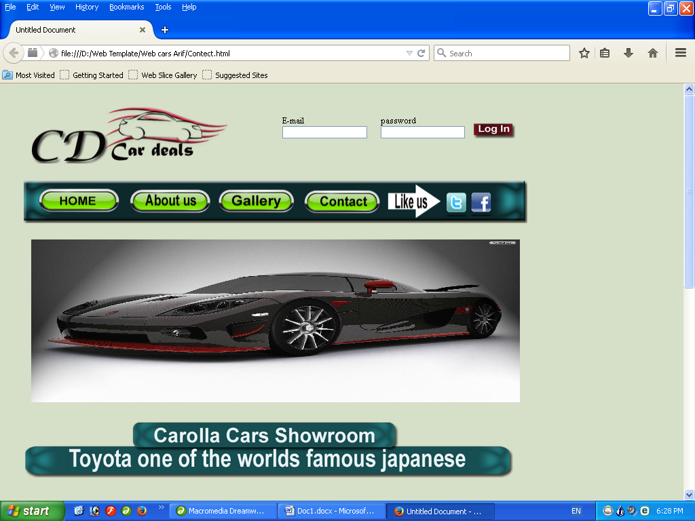

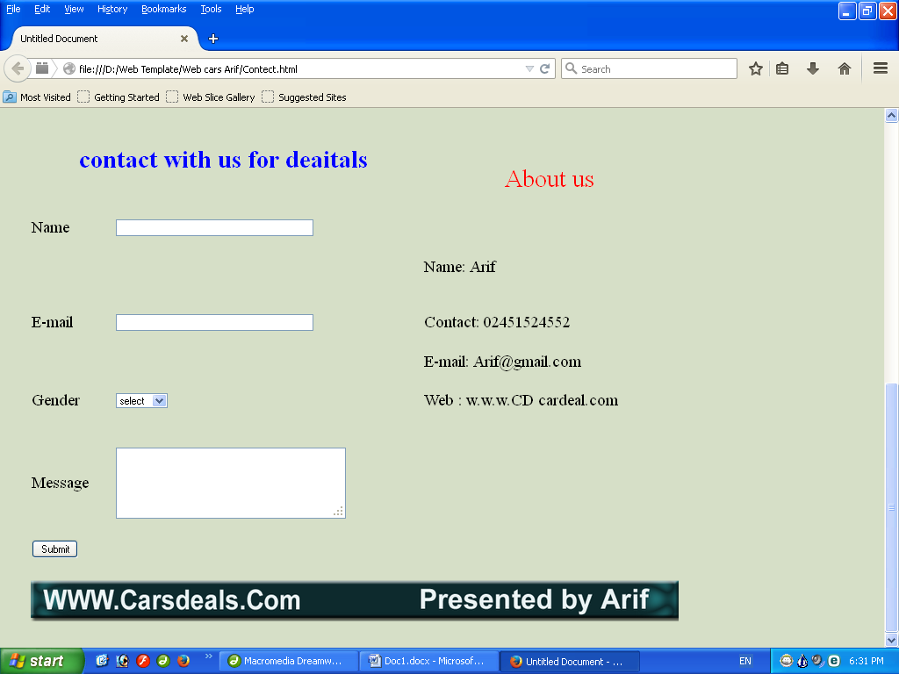

**Page Contact**

<!DOCTYPE html PUBLIC "-//W3C//DTD XHTML 1.0 Transitional//EN" "http://www.w3.org/TR/xhtml1/DTD/xhtml1-transitional.dtd">

<html xmlns="http://www.w3.org/1999/xhtml">

<head>

<meta http-equiv="Content-Type" content="text/html; charset=iso-8859-1" />

<title>Untitled Document</title>

<style type="text/css">

<!--

.style4 {

font-size: 36px;

color: #0000FF;

font-weight: bold;

}

.style6 {font-size: 24px}

.style7 {

font-size: 36px;

color: #FF0000;

}

body {

background-color: #d6dfc7;

}

-->

</style>

</head>

<body>

<table width="1000">

<tr>

<td><table width="950" align="center">

<tr>

<td width="9">&nbsp;</td>

<td width="376">&nbsp;</td>

<td width="14">&nbsp;</td>

<td width="516">&nbsp;</td>

<td width="11">&nbsp;</td>

</tr>

<tr>

<td>&nbsp;</td>

<td><img src="images/Arif_03.png" width="374" height="109" /></td>

<td>&nbsp;</td>

<td><table width="512" height="72">

<tr>

<td width="80">&nbsp;</td>

<td width="145"><form id="form1" name="form1" method="post" action="">

<label>E-mail

<input type="text" name="textfield" />

</label>

</form> </td>

<td width="19">&nbsp;</td>

<td width="144"><form id="form2" name="form2" method="post" action="">

<label>password

<input type="text" name="textfield2" />

</label>

</form> </td>

<td width="100" align="center" valign="bottom"><img src="images/Arif_06.png" width="80" height="30" border="0" usemap="#Map2" /></td>

</tr>

<tr>

<td height="21" colspan="5">&nbsp;</td>

</tr>

</table></td>

<td>&nbsp;</td>

</tr>

<tr>

<td>&nbsp;</td>

<td>&nbsp;</td>

<td>&nbsp;</td>

<td>&nbsp;</td>

<td>&nbsp;</td>

</tr>

</table>

<table width="950" align="center">

<tr>

<td>&nbsp;</td>

<td><img src="images/Arif_11.png" width="927" height="81" border="0" usemap="#Map" /></td>

<td>&nbsp;</td>

</tr>

<tr>

<td>&nbsp;</td>

<td>&nbsp;</td>

<td>&nbsp;</td>

</tr>

</table>

<table width="950" align="center">

<tr>

<td>&nbsp;</td>

<td><div align="center">

<object classid="clsid:D27CDB6E-AE6D-11cf-96B8-444553540000" codebase="http://download.macromedia.com/pub/shockwave/cabs/flash/swflash.cab#version=7,0,19,0" width="900" height="300">

<param name="movie" value="Templates/Arif 1.swf" />

<param name="quality" value="high" />

<embed src="Templates/Arif 1.swf" quality="high" pluginspage="http://www.macromedia.com/go/getflashplayer" type="application/x-shockwave-flash" width="900" height="300"></embed>

</object>

</div></td>

<td>&nbsp;</td>

</tr>

<tr>

<td>&nbsp;</td>

<td>&nbsp;</td>

<td>&nbsp;</td>

</tr>

</table>

<table width="950" align="center">

<tr>

<td>&nbsp;</td>

<td><img src="images/Arif_15.png" width="901" height="104" /></td>

<td>&nbsp;</td>

</tr>

<tr>

<td>&nbsp;</td>

<td>&nbsp;</td>

<td>&nbsp;</td>

</tr>

</table>

<table width="950" align="center">

<tr>

<td>&nbsp;</td>

<td colspan="3"><p align="center" class="style4">contact with us for deaitals </p> </td>

<td>&nbsp;</td>

<td rowspan="3"><div align="center"><span class="style7">About us </span></div></td>

<td width="14">&nbsp;</td>

</tr>

<tr>

<td>&nbsp;</td>

<td>&nbsp;</td>

<td>&nbsp;</td>

<td>&nbsp;</td>

<td>&nbsp;</td>

<td>&nbsp;</td>

</tr>

<tr>

<td>&nbsp;</td>

<td><span class="style6">Name</span></td>

<td>&nbsp;</td>

<td><form id="form3" name="form3" method="post" action="">

<label>

<input name="textfield3" type="text" size="40" />

</label>

</form> </td>

<td>&nbsp;</td>

<td>&nbsp;</td>

</tr>

<tr>

<td>&nbsp;</td>

<td><span class="style6"></span></td>

<td>&nbsp;</td>

<td>&nbsp;</td>

<td>&nbsp;</td>

<td><p class="style6">Name: Arif </p>

</td>

<td>&nbsp;</td>

</tr>

<tr>

<td>&nbsp;</td>

<td><span class="style6">E-mail</span></td>

<td>&nbsp;</td>

<td><form id="form4" name="form4" method="post" action="">

<label>

<input name="textfield4" type="text" size="40" />

</label>

</form> </td>

<td>&nbsp;</td>

<td><p class="style6">Contact: 02451524552</p>

</td>

<td>&nbsp;</td>

</tr>

<tr>

<td>&nbsp;</td>

<td><span class="style6"></span></td>

<td>&nbsp;</td>

<td>&nbsp;</td>

<td>&nbsp;</td>

<td><span class="style6">E-mail: Arif@gmail.com </span></td>

<td>&nbsp;</td>

</tr>

<tr>

<td>&nbsp;</td>

<td><span class="style6">Gender</span></td>

<td>&nbsp;</td>

<td><form id="form5" name="form5" method="post" action="">

<label>

<select name="select">

<option>select</option>

<option>mail</option>

<option>fe male</option>

</select>

</label>

</form> </td>

<td>&nbsp;</td>

<td><p class="style6">Web : w.w.w.CD cardeal.com </p>

</td>

<td>&nbsp;</td>

</tr>

<tr>

<td>&nbsp;</td>

<td><span class="style6"></span></td>

<td>&nbsp;</td>

<td>&nbsp;</td>

<td>&nbsp;</td>

<td>&nbsp;</td>

<td>&nbsp;</td>

</tr>

<tr>

<td>&nbsp;</td>

<td><span class="style6">Message</span></td>

<td>&nbsp;</td>

<td><form id="form6" name="form6" method="post" action="">

<label>

<textarea name="textarea" cols="40" rows="5"></textarea>

</label>

</form> </td>

<td>&nbsp;</td>

<td>&nbsp;</td>

<td>&nbsp;</td>

</tr>

<tr>

<td>&nbsp;</td>

<td>&nbsp;</td>

<td>&nbsp;</td>

<td>&nbsp;</td>

<td>&nbsp;</td>

<td>&nbsp;</td>

<td>&nbsp;</td>

</tr>

<tr>

<td>&nbsp;</td>

<td><form id="form7" name="form7" method="post" action="">

<label>

<input type="submit" name="Submit" value="Submit" />

</label>

</form> </td>

<td>&nbsp;</td>

<td>&nbsp;</td>

<td>&nbsp;</td>

<td>&nbsp;</td>

<td>&nbsp;</td>

</tr>

<tr>

<td>&nbsp;</td>

<td>&nbsp;</td>

<td>&nbsp;</td>

<td>&nbsp;</td>

<td>&nbsp;</td>

<td>&nbsp;</td>

<td>&nbsp;</td>

</tr>

</table>

<table width="950" align="center">

<tr>

<td>&nbsp;</td>

<td><img src="images/Log-In_23.png" width="923" height="60" /></td>

<td>&nbsp;</td>

</tr>

<tr>

<td>&nbsp;</td>

<td>&nbsp;</td>

<td>&nbsp;</td>

</tr>

</table></td>

</tr>

</table>

<map name="Map" id="Map"><area shape="rect" coords="39,24,166,55" href="Home.html" />

<area shape="rect" coords="211,25,330,58" href="About us.html" />

<area shape="rect" coords="375,27,487,55" href="gallery 1.html" />

<area shape="rect" coords="524,26,652,58" href="Contect.html" />

<area shape="rect" coords="781,32,812,56" href="#" /><area shape="rect" coords="827,31,858,59" href="#" /></map>

<map name="Map2" id="Map2"><area shape="rect" coords="1,0,78,23" href="#" /></map></body>

</html>

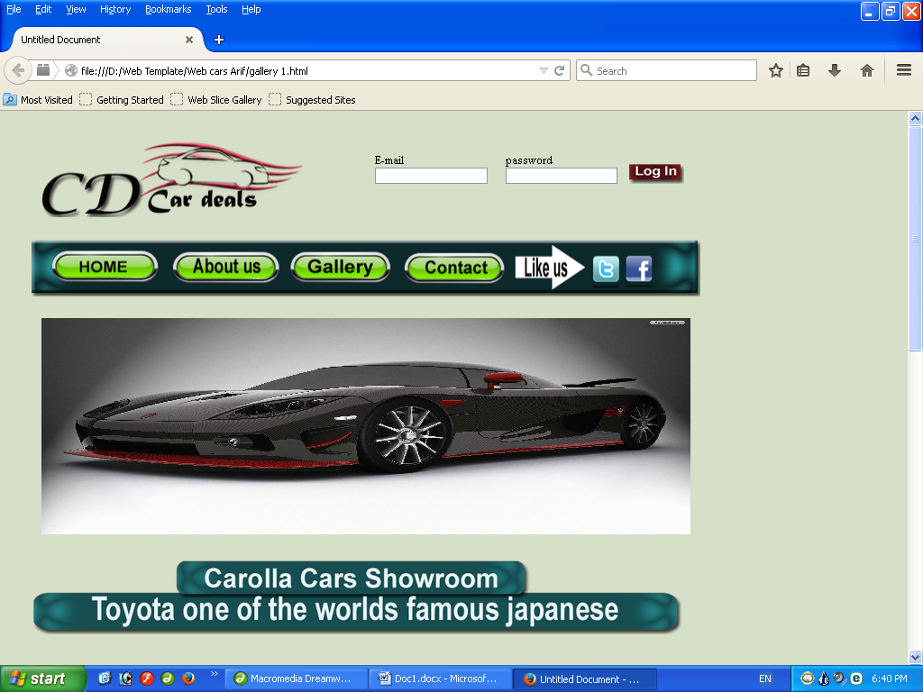

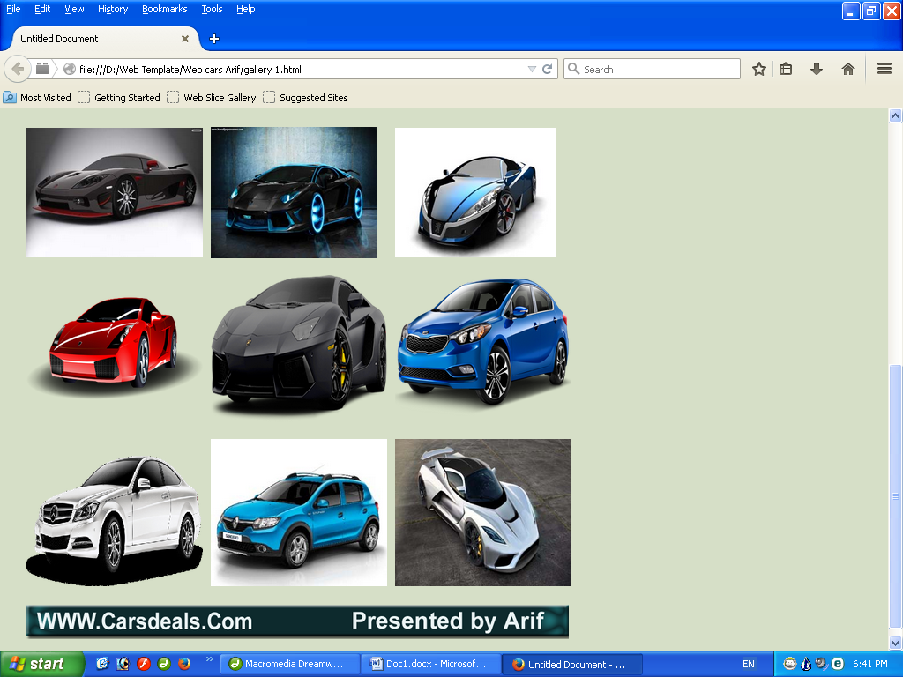

**Page Gllery**

<!DOCTYPE html PUBLIC "-//W3C//DTD XHTML 1.0 Transitional//EN" "http://www.w3.org/TR/xhtml1/DTD/xhtml1-transitional.dtd">

<html xmlns="http://www.w3.org/1999/xhtml">

<head>

<meta http-equiv="Content-Type" content="text/html; charset=iso-8859-1" />

<title>Untitled Document</title>

<style type="text/css">

<!--

.style1 {

font-size: 36px;

font-weight: bold;

}

.style2 {font-size: 24px}

body {

background-color: #d6dfc7;

}

-->

</style>

</head>

<body>

<table width="1000">

<tr>

<td><table width="950" align="center">

<tr>

<td width="9">&nbsp;</td>

<td width="376">&nbsp;</td>

<td width="14">&nbsp;</td>

<td width="516">&nbsp;</td>

<td width="11">&nbsp;</td>

</tr>

<tr>

<td>&nbsp;</td>

<td><img src="images/Arif_03.png" width="374" height="109" /></td>

<td>&nbsp;</td>

<td><table width="512" height="72">

<tr>

<td width="80">&nbsp;</td>

<td width="145"><form id="form1" name="form1" method="post" action="">

<label>E-mail

<input type="text" name="textfield" />

</label>

</form> </td>

<td width="19">&nbsp;</td>

<td width="144"><form id="form2" name="form2" method="post" action="">

<label>password

<input type="text" name="textfield2" />

</label>

</form> </td>

<td width="100" align="center" valign="bottom"><img src="images/Arif_06.png" width="80" height="30" border="0" usemap="#Map2" /></td>

</tr>

<tr>

<td height="21" colspan="5">&nbsp;</td>

</tr>

</table></td>

<td>&nbsp;</td>

</tr>

<tr>

<td>&nbsp;</td>

<td>&nbsp;</td>

<td>&nbsp;</td>

<td>&nbsp;</td>

<td>&nbsp;</td>

</tr>

</table>

<table width="950" align="center">

<tr>

<td>&nbsp;</td>

<td><a href="#"><img src="images/Arif_11.png" width="927" height="81" border="0" usemap="#Map" /></a></td>

<td>&nbsp;</td>

</tr>

<tr>

<td>&nbsp;</td>

<td>&nbsp;</td>

<td>&nbsp;</td>

</tr>

</table>

<table width="950" align="center">

<tr>

<td>&nbsp;</td>

<td><div align="center">

<object classid="clsid:D27CDB6E-AE6D-11cf-96B8-444553540000" codebase="http://download.macromedia.com/pub/shockwave/cabs/flash/swflash.cab#version=7,0,19,0" width="900" height="300">

<param name="movie" value="Templates/Arif 1.swf" />

<param name="quality" value="high" />

<embed src="Templates/Arif 1.swf" quality="high" pluginspage="http://www.macromedia.com/go/getflashplayer" type="application/x-shockwave-flash" width="900" height="300"></embed>

</object>

</div></td>

<td>&nbsp;</td>

</tr>

<tr>

<td>&nbsp;</td>

<td>&nbsp;</td>

<td>&nbsp;</td>

</tr>

</table>

<table width="950" align="center">

<tr>

<td>&nbsp;</td>

<td><img src="images/Arif_15.png" width="901" height="104" /></td>

<td>&nbsp;</td>

</tr>

<tr>

<td>&nbsp;</td>

<td>&nbsp;</td>

<td>&nbsp;</td>

</tr>

</table>

<table width="950" align="center">

<tr>

<td>&nbsp;</td>

<td>&nbsp;</td>

<td>&nbsp;</td>

</tr>

<tr>

<td>&nbsp;</td>

<td>&nbsp;</td>

<td>&nbsp;</td>

</tr>

</table>

<table width="950" align="center">

<tr>

<td width="9">&nbsp;</td>

<td width="300"><img src="gallery/bottom/black_sport_car_wallpaper_005ce.jpg" width="300" height="219" border="0" usemap="#Map3" /></td>

<td width="15">&nbsp;</td>

<td width="284"><img src="gallery/bottom/car-1.jpg" width="284" height="223" border="0" usemap="#Map4" /></td>

<td width="22">&nbsp;</td>

<td width="280"><img src="gallery/bottom/car-03.jpg" width="273" height="220" border="0" usemap="#Map5" /></td>

<td width="8">&nbsp;</td>

</tr>

<tr>

<td>&nbsp;</td>

<td>&nbsp;</td>

<td>&nbsp;</td>

<td>&nbsp;</td>

<td>&nbsp;</td>

<td>&nbsp;</td>

<td>&nbsp;</td>

</tr>

<tr>

<td>&nbsp;</td>

<td><img src="gallery/bottom/car-30984_640.png" width="300" height="250" border="0" usemap="#Map6" /></td>

<td>&nbsp;</td>

<td><img src="gallery/bottom/car.png" width="300" height="250" border="0" usemap="#Map7" /></td>

<td>&nbsp;</td>

<td><img src="gallery/bottom/hero_forte_2014--kia-1920x.png" width="300" height="250" border="0" usemap="#Map8" /></td>

<td>&nbsp;</td>

</tr>

<tr>

<td>&nbsp;</td>

<td>&nbsp;</td>

<td>&nbsp;</td>

<td>&nbsp;</td>

<td>&nbsp;</td>

<td>&nbsp;</td>

<td>&nbsp;</td>

</tr>

<tr>

<td>&nbsp;</td>

<td><img src="gallery/bottom/mercedes_PNG1882.png" width="300" height="250" border="0" usemap="#Map9" /></td>

<td>&nbsp;</td>

<td><img src="gallery/bottom/ncs-red-renault.jpg" width="300" height="250" border="0" usemap="#Map10" /></td>

<td>&nbsp;</td>

<td><img src="gallery/bottom/with-300-mph-in-its-sights-the-fastest-car-in-the-world-just-got-a-lot-faster.jpg" width="300" height="250" border="0" usemap="#Map11" /></td>

<td>&nbsp;</td>

</tr>

<tr>

<td>&nbsp;</td>

<td>&nbsp;</td>

<td>&nbsp;</td>

<td>&nbsp;</td>

<td>&nbsp;</td>

<td>&nbsp;</td>

<td>&nbsp;</td>

</tr>

</table>

<table width="950" align="center">

<tr>

<td>&nbsp;</td>

<td><img src="images/Log-In_23.png" width="923" height="60" /></td>

<td>&nbsp;</td>

</tr>

<tr>

<td>&nbsp;</td>

<td>&nbsp;</td>

<td>&nbsp;</td>

</tr>

</table></td>

</tr>

</table>

<map name="Map" id="Map">

<area shape="rect" coords="34,25,162,54" href="Home.html" />

<area shape="rect" coords="209,22,333,55" href="About us.html" />

<area shape="rect" coords="371,23,489,58" href="gallery 1.html" />

<area shape="rect" coords="527,26,647,56" href="Contect.html" />

<area shape="rect" coords="782,28,809,60" href="#" /><area shape="rect" coords="826,27,860,58" href="#" /></map>

<map name="Map2" id="Map2"><area shape="rect" coords="7,6,80,24" href="#" /></map>

<map name="Map3" id="Map3">

<area shape="rect" coords="3,1,301,215" href="gallery/Large pic/black_sport_car_wallpaper_005ce.jpg" />

</map>

<map name="Map4" id="Map4">

<area shape="rect" coords="5,4,285,217" href="gallery/Large pic/car-1.jpg" />

</map>

<map name="Map5" id="Map5"><area shape="rect" coords="4,0,275,218" href="gallery/Large pic/car-03.jpg" />

</map>

<map name="Map6" id="Map6"><area shape="rect" coords="6,4,296,249" href="gallery/Large pic/car-30984_640.png" />

</map>

<map name="Map7" id="Map7">

<area shape="rect" coords="5,2,298,246" href="gallery/Large pic/car.png" />

</map>

<map name="Map8" id="Map8"><area shape="rect" coords="5,7,299,247" href="gallery/Large pic/hero_forte_2014--kia-1920x.png" />

</map>

<map name="Map9" id="Map9"><area shape="rect" coords="6,6,297,248" href="gallery/Large pic/mercedes_PNG1882.png" />

</map>

<map name="Map10" id="Map10"><area shape="rect" coords="3,4,301,243" href="gallery/Large pic/ncs-red-renault.jpg" />

</map>

<map name="Map11" id="Map11"><area shape="rect" coords="7,7,294,244" href="gallery/Large pic/with-300-mph-in-its-sights-the-fastest-car-in-the-world-just-got-a-lot-faster.jpg" />

</map></body>

</html>